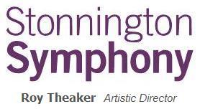
Symphony in a Day
Saturday 6 October

On Saturday 6 October Stonnington Symphony will be running Symphony in a Day at the Malvern Town Hall. Rehearsals commence at 10:00am and finish at 4:00pm. A performance will commence at 5:30pm.
Morning and afternoon tea will be provided, however, participants must supply their own lunch.
Parents /Guardians are asked to collect their children at 4:00pm and return for the performance at 5:30pm.

To ensure that your child can attend this event, please complete the form below and return to admin@stonningtonsymphony.org.au as soon as possible. Without a permission slip your child cannot attend.

Name of Child
Emergency Contact Name
Emergency Contact Number
Allergies/Medical Conditions

- I give permission for my child to attend Symphony in a Day on Saturday 6 October at the Malvern Town Hall between 10:00am and 4:00pm
- I agree that Stonnington Symphony Inc may use photographic, video, or digital images in which my child may appear, in publications (including but not limited to brochures, booklets, reports, press releases, websites) for the purposes of promotion, public relations and fund-raising connected with Stonnington Symphony.

Parent/Guardian Signature:
Parent/Guardian Name:
Date:

